HEATSINK CYCLING REFRIGERATED AIR DRYER (3250-19200 SCFM)
PRODUCT SPECIFICATION

This Product Specification is for a complete mechanical refrigerated drying system for the removal of moisture, oil vapor and other contaminants from a compressed air or gas stream. This process is accomplished by cooling the gas with a refrigeration unit to a temperature at which the contaminants condense and are separated from the gas stream. The Specification includes information for a range of dryers that can be applied to air systems of varying size

SCOPE

The dryer shall be complete in all respects, including integral component equipment, inter-connecting piping, wiring and controls. The dryer shall only require connection to utilities furnished by others.

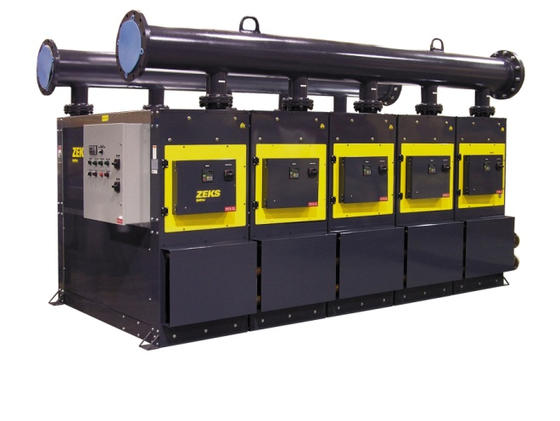
For reference only
EXCHANGER TECHNOLOGY

All chiller and precooler / reheater heat exchangers shall be manufactured entirely from stainless steel. The heat exchange surfaces shall be a corrugated and folded stainless steel sheet contained within a fully-welded cylindrical stainless steel shell.

There shall be no other extraneous materials such as silver or copper braze alloys, lead or tin solder, nor shall any adhesives, gaskets or other sealing method be used.

Exchangers shall be designed with cross corrugated and folded heat exchange surfaces to enhance air flow turbulence, thus providing superior heat transfer over a wide range of air flow conditions with low pressure drop.

Additionally, exchanger design shall provide a large open multipath area (5 times that of shell & tube design) to provide resistance to fouling.

COMPONENTS AND CONSTRUCTION

Each dryer module shall be complete with the following items:

- Precooler/Reheater exchanger
- Air chiller
- Centrifugal air/moisture separator
- Thermal mass cooling system
- Thermal mass circulating system
- Refrigeration system equipped with independent fully-hermetic compressor and water or air-cooled condenser
- Drain to automatically discharge condensate
- Microprocessor based control system to regulate and monitor system operation

PRECOOLER/REHEATER

Dryer shall be equipped with stainless steel heat exchangers to precool incoming compressed air and reheat outgoing compressed air. Air-to-air heat exchangers shall be constructed completely with stainless steel. The maximum design pressure shall be 220 psig.

AIR CHILLER

Compressed air from the precooler/reheater shall be delivered to the refrigerated chiller section. The chiller shall consist of stainless steel heat exchangers, where heat from the compressed air is exchanged with the thermal mass fluid.

REFRIGERATED AIR DRYER (Cont)

CENTRIFUGAL AIR/MOISTURE SEPARATOR

A vertical air/moisture separator shall be located adjacent to the chiller section. Compressed air and water condensed in the chiller section shall be delivered to the separator for the separation and subsequent removal of the water from the compressed air.

Separation shall be performed at the coldest point in the system by means of centrifugal acceleration, expansion into an area of low velocity with sump area and change of air flow direction. These separation mechanisms shall provide for separation efficiency in excess of 99%.

THERMAL MASS COOLING SYSTEM

The thermal mass cooling system shall consist of a centralized thermal mass reservoir, thermal mass fluid and stainless steel evaporators. Refrigerant from each refrigeration system shall be circulated within the evaporator of each module, liberating heat from the thermal mass fluid.

The thermal mass shall thus allow the refrigerant compressor to cycle on and off automatically depending on the heat load to the dryer. Reservoir shall be manufactured from carbon steel, be seem welded and fully insulated with 1” minimum foam insulation. The storage container and exchanger system shall be designed to deliver a 38°F PDP.

THERMAL MASS CIRCULATING SYSTEM

Thermal mass fluid shall be transferred to the thermal mass fluid to air heat exchanger via the thermal mass fluid pump. Pump shall be maintenance-free, cartridge circulator pump. Pump shall run continuously to maintain flow through the air chiller at all times.

REFRIGERATION SYSTEM

The refrigeration system for each module shall be designed to dry a set amount of compressed air and shall consist of one hermetic reciprocating-type compressor, refrigerant feed system and air or water-cooled condenser.

No hot gas by-pass valve or similar capacity modulating device shall be used in the refrigeration system.

R-404A shall be used to minimize environmental hazard. The amount of refrigerant shall be minimized through use of a measured charge system, to prevent liquid refrigerant floodback to the hermetic compressor.

MICROPROCESSOR CONTROLS AND INSTRUMENTATION

The chiller section and associated refrigeration system for each module shall be controlled and
monitored by a fully integrated microprocessor. The standard microprocessor shall incorporate
the following features:

- Percent energy savings digital readout
- Chiller temperature digital readout
- Suction temperature digital readout
- Suction pressure digital readout
- Discharge pressure digital readout
- Dryer running time
- Diagnostic memory
- Automatic dryer restart
- Remote start/stop
- Remote communication ready
- High discharge pressure cutout alarm
- High evaporator temperature alarm
- Low evaporator temperature alarm
- Compressor heater delay

The first module in the system shall feature a DPC Plus controller that provides the following
additional features:

- Compressed air inlet pressure digital readout
- Compressed air outlet pressure digital readout
- Compressed air inlet temperature digital readout
- Compressed air outlet temperature digital readout

END PRODUCT SPECIFICATION

