PRODUCT SPECIFICATION
DESICCANT AIR DRYER – HEATLESS REGENERATION (90-5000 SCFM)

This Product Specification is for twin-tower, desiccant-type dryers to be used for removal of water and contaminants from compressed air to a specified degree. The dryers do not include a heater component to assist regeneration of the desiccant media. The Specification includes information for a range of dryers that can be applied to air systems of varying size.

SCOPE
Unit shall be factory assembled, self-contained and completed in all respects including component equipment, interconnection piping, wiring, controls, and instrumentation. Unit shall be free standing, requiring only inlet/outlet air connections and electrical connection. All controls and instruments shall be factory set/calibrated so as to provide for "turn-key" operation.

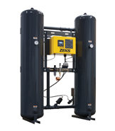
For reference only

OPERATION
Dryer shall be designed and assembled to operate as follows:

- Continuously and automatically
- Drying and Regeneration cycle shall be ten (10) minutes.
- The portion of air used in regeneration shall be expanded to atmospheric pressure at the dry air outlet of the dryer, and routed to and through the off-line (regenerating) tower.

- Regeneration shall be accomplished by passing a portion of dry expanded air through the regenerating tower in a reverse direction of the drying flow path and then purging it to atmosphere.
- The off-line tower shall be gradually brought back up to line pressure prior to tower switch over. This shall prevent desiccant attrition and dusting and premature failure of downstream particulate filter elements.
- Velocity through the desiccant towers shall not exceed 65 fpm. This velocity shall provide adequate contact time to provide an efficient, consistent dewpoint. Pressure drop across the dryer shall not exceed 3.5 PSIG at design conditions.

PERFORMANCE
Dryer shall provide for water removal so that the air moisture level shall not exceed -40°F pressure dew point at all times.

Dryer shall perform at saturated inlet air temperatures of up to 120°F and ambient temperatures between 40°F and 120°F. Dryer capacity will be reduced when inlet temperature exceeds 100°F.

COMPONENTS AND CONSTRUCTION
Dryer Towers shall be ASME coded pressure vessels constructed from carbon steel.


HEATLESS DESICCANT AIR DRYER (Cont.)

To maintain lowest possible pressure drop, the inlet flow valves shall be stainless steel angle seat valves on the 90-600 models and high performance butterfly on the 800-5000 models. The purge valves shall be stainless steel angle seat valves for all models. These valves shall contain NO LUBRICATION OF ANY KIND. (This shall prevent desiccant bed contamination.)
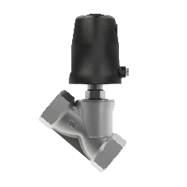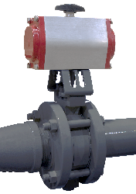
Stainless Steel angle seat valve
High performance butterfly valve

Outlet dry air flow shall be controlled through the use of a dual check valve manifold assembly installed at the top of the dryer towers to prevent dust contamination.

Each tower shall have stainless steel desiccant support and removable stainless steel air diffusion screen.

Towers shall be primed and then finish coated with acrylic enamel, industrial grade paint. Each dryer tower shall be provided with separate fill and drain ports, suitable for connection to a vacuum-type filling or extraction system.

Each tower shall be provided with a pressure gauge and safety relief valve.

Safety relief valves (reference only)

PIPING AND FITTINGS
All piping shall be carbon steel, Schedule 40 designation. All fittings and interconnecting piping shall be black iron with 150# suitable unions positioned for ease of assemble and disassembly.

Threaded components shall conform to the National Pipe Thread (NPT) standards.

Control Air lines shall be 1/4 inch heavy duty flexible nylon tubing. The use of nylon tubing shall be limited to control air lines and sample air lines. Tubing shall be connected by the use of push-on type fittings for ease of assembly and disassembly.

All components that use pilot air for operation are protected by an in-line filter. Air supply shall be both clean and dry.

DRYER FLOW PATH
DRYING FLOW SHALL BE UPWARDS through the beds, REGENERATION flow shall be downward (Counter-current flow).

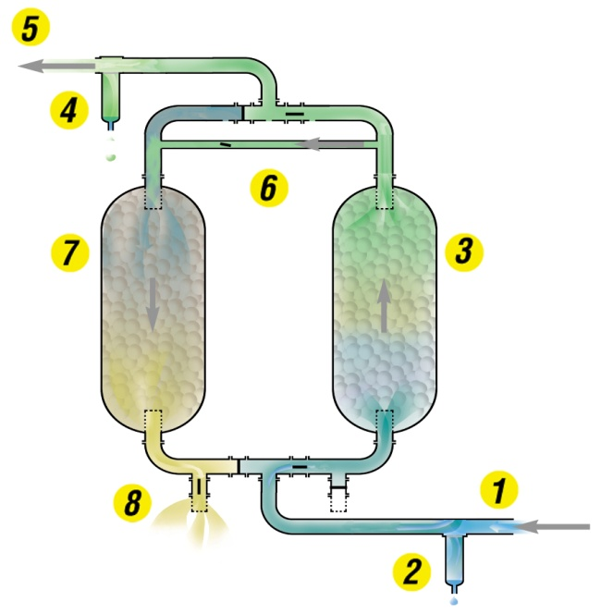
- Moist compressed air enters dryer

- Coalescing prefilter protects dryer

- Inlet flow valves automatically direct moist compressed air through online (drying) tower. As air passes over the desiccant the moisture is adsorbed by the desiccant. Heat is generated by this removal of the moisture from the air (heat-of-adsorption)

HEATLESS DESICCANT AIR DRYER (Cont.)

- Particulate afterfilter protects pneumatic tools and equipment

- Dry air exits dryer for use.

- A portion of the dry purge air is directed to the offline tower for regeneration

- Purge air flows counter-current to regenerate the desiccant media in the offline (regenerating) tower, assisted by the heat-of-adsorption

- Moisture is exhausted to atmosphere through muffler.

TOWER PRESSURIZATION / DEPRESSURIZATION
Pressurization/depressurization of the two dryer pressure vessels (towers) will be automatically controlled within the following process:

- The off line tower shall be brought up to line pressure gradually prior to tower switching.
- Tower switching shall occur at full line pressure for the purpose of reducing desiccant attrition and the subsequent dusting and the resultant premature aging of afterfilter elements.
- A pressure gauge on each dryer tower shall act as a visual indicator that tower switching has occurred.
- The dual purge air valves shall be fitted with exhaust silencers so as to minimize noise during tower depressurization and purging.

DESICCANT BED
Dryer shall be filled with Activated Alumina desiccant. Grade A minimum.

Desiccant volume shall be sufficient to provide stated outlet dew point in maximum operating conditions of moisture load and temperature.

Desiccant shall be rated for wet air service and shall not fracture in the presence of liquid water. Silica Gel shall not be acceptable.

NO CHLORIDE TYPE ABSORBENTS WILL BE ALLOWED.

Desiccant life shall be 5-7 years provided no oil or condensable hydrocarbons are allowed to migrate into the desiccant beds.

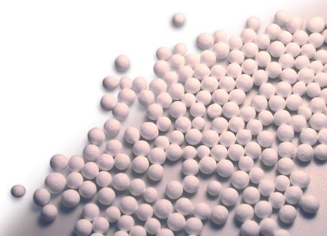

CONTROLS AND INSTRUMENTATION
Main Control enclosure shall be constructed in accordance with NEMA standards; factory mounted directly on the unit and shall include all controls, indicating lights, switches, and other instrumentation devices.

Drying System shall be shipped functionally tested so that only single entry electrical connection is necessary for the unit's entire electrical system.

Standard timer shall be solid state type for maintenance free operation. Mechanical (Cam type) timers which are susceptible to wear and subsequent failure are not acceptable. Programmable controllers, due to the requirement for on-Site program access capability shall not be used.

Unit shall include pressure gauges mounted on each tower.

END PRODUCT SPECIFICATION

