NON-CYCLING REFRIGERATED AIR DRYER (3250-19200 SCFM)
PRODUCT SPECIFICATION

This Product Specification is for a complete mechanical refrigerated drying system for the removal of moisture, oil vapor and other contaminants from a compressed air or gas stream. This process is accomplished by cooling the gas with a refrigeration unit to a temperature at which the contaminants condense and are separated from the gas stream. The Specification includes information for a range of dryers that can be applied to air systems of varying size.

SCOPE

The dryer shall be complete in all respects, including integral component equipment, inter-connecting piping, wiring and controls. The dryer shall only require connection to utilities furnished by others.

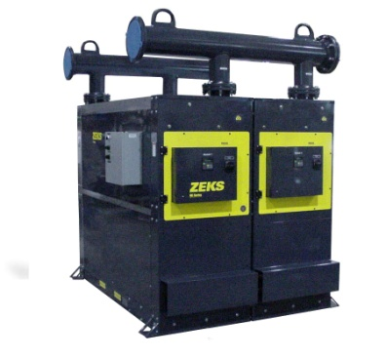
For reference only

EXCHANGER TECHNOLOGY

All heat exchangers shall be manufactured entirely from stainless steel. The heat exchange surfaces shall be a corrugated and folded SS sheet contained within a fully-welded, cylindrical SS shell.

There shall be no other extraneous materials such as silver or copper braze alloys, lead or tin solder, nor shall any adhesives, gaskets or other sealing method be used.

Exchangers shall be designed with cross corrugated and folded heat exchange surfaces to enhance air flow turbulence, thus providing superior heat transfer over a wide range of air flow conditions with low pressure drop.

Additionally, exchanger design shall provide a large open multipath area (5 times that of shell & tube design) to provide resistance to fouling.

COMPONENTS AND CONSTRUCTION

Each dryer system shall be complete with the following items:

- Precooler/Reheater exchanger
- Refrigerant chiller section
- Centrifugal air/moisture separator
- Refrigeration system equipped with hermetically sealed compressor and air or water cooled condenser
- Condensate Drain
- Control system to initiate and monitor system operation.

PRECOOLER/REHEATER

Each dryer module shall be equipped with stainless steel heat exchangers to precool incoming compressed air and reheat outgoing compressed air. Air-to-air heat exchanger shall be constructed completely with stainless steel. The maximum design pressure shall be 220 psig.

AIR CHILLER

Compressed air from the precooler/reheater shall be delivered to the chiller section. The chiller section shall consist of stainless steel heat exchanger/refrigerant evaporator(s). Exchanger surfaces shall be arranged in a counter flow orientation to further optimize heat transfer. The chiller section shall be designed to deliver a 38°F PDP. Compressed air, delivered to the chiller section, shall be cooled by direct exchange of heat across heat exchanger surfaces.
REFRIGERATED AIR DRYER (Cont.)

CENTRIFUGAL AIR/MOISTURE SEPARATOR

A vertical air/moisture separator shall be located after the air chiller. Compressed air and water condensed in the air chiller shall be delivered to the separator for the separation and subsequent removal of the water from the compressed air

Separation shall be performed at the coldest point in the system by means of centrifugal acceleration, expansion into an area of low velocity with sump area and change of air flow direction. These separation mechanisms shall provide for separation efficiency in excess of 99%.

REFRIGERATION SYSTEM

The refrigeration system for each module shall consist of one hermetic reciprocating type compressor, refrigerant feed system and air or water cooled condenser. A hot gas by-pass valve shall be used in the refrigeration system.

Refrigerant R-404A shall be used to minimize environmental hazard. The amount of refrigerant shall be minimized through use of a measured charge system, to prevent liquid refrigerant floodback to the hermetic compressor.

MICROPROCESSOR CONTROLS AND INSTRUMENTATION

The chiller section and associated refrigeration system shall be controlled and monitored by a fully integrated microprocessor. A hot-gas bypass valve shall be used on each module to prevent freeze-up. The standard microprocessor shall incorporate the following features:

- Evaporator temperature digital readout
- Suction temperature digital readout
- Suction pressure digital readout
- Discharge pressure digital readout
- Dryer running time
- Diagnostic memory
- Condensate drain test switch
- Condensate drain time adjustment
- Automatic dryer restart
- Remote start/stop
- Remote communication ready
- High discharge pressure cutout alarm
- High evaporator temperature alarm
- Low evaporator temperature alarm
- Compressor heater delay

The first module in the system shall feature an enhanced controller that provides the following
additional features:

- Compressed air inlet pressure digital readout
- Compressed air outlet pressure digital readout
- Compressed air inlet temperature digital readout
- Compressed air outlet temperature digital readout

END PRODUCT SPECIFICATION

