PRODUCT SPECIFICATION
DESICCANT AIR DRYER – HEATED BLOWER REGENERATION (150 – 8000 SCFM)

This Product Specification is for twin-tower, desiccant-type dryers to be used for removal of water and contaminants from compressed air to a specified degree. The dryers include a blower that forces atmospheric air through an external heater to assist regeneration of the desiccant media. The Specification includes information for a range of dryers that can be applied to air systems of varying size.

SCOPE
Unit shall be factory assembled, self contained and complete in all respects including component equipment, interconnecting piping, wiring, controls, and instrumentation. Unit shall be free standing, requiring only inlet/outlet air connections and electrical connection. All controls and instruments shall be factory set/calibrated so as to provide for "turn- key" operation.

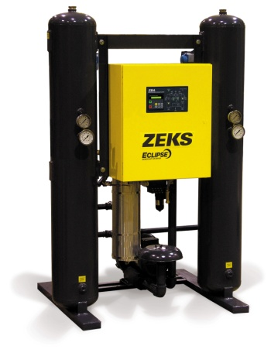
For reference only

OPERATION
Dryer shall be designed and assembled to operate as follows:

- Continuous and automatically.
- Drying and Regenerating cycle shall be a minimum of 8 hours (4 hours drying, 4 hours regenerating).

- Regeneration cycle shall consist of 3 hours heating and 1 hour cool down.
- Desiccant regeneration shall be accomplished by a blower that forces atmospheric air through an external heater and then though the wet desiccant bed of the tower being regenerated (off-line).
- Water vapor collected in the wet desiccant bed is desorbed and enters the hot purge air stream.
- The hot, wet, purge air stream is then carried out of the dryer and vented to atmosphere.

PERFORMANCE
Dryer shall provide for water removal to produce a -40°F pressure dew point.

Dryer shall perform at saturated inlet air temperatures of up to 100°F, and ambient temperatures from 40°F to 120°F. Inlet pressure will be 100 psig minimum.

Note: Dryer capacity is reduced when inlet air temperatures are greater than and/or operating pressures are less than design parameters.

COMPONENTS AND CONSTRUCTION

Dryer Towers shall be ASME coded pressure vessels constructed from carbon steel.



HEATED BLOWER DESICCANT AIR DRYER (Cont.)

To maintain lowest possible pressure drop, dryer shall have inlet and outlet connections of full port, high performance, flanged butterfly valves for valve sizes 2-1/2" and larger. High Performance ball valves shall be used for valves 2" and smaller.

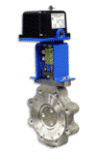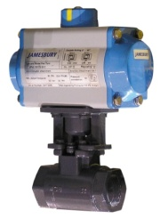
Actuated ball valve
Actuated butterfly valve
BLOWER

Tower shall be equipped with stainless steel desiccant supports and stainless steel air diffusion screens.

Each dryer tower shall be provided with separate fill and drain ports.

A safety relief valve shall be included on each tower.

Safety relief valves (reference only)

PIPING AND FITTINGS
All piping shall be carbon steel, schedule 40 designation. All fittings and interconnecting
piping shall be flanged or provided with unions for ease of assembly and disassembly.

Flanged components shall conform to the American National Standards Institute (ANSI).

Threaded components shall conform to the National Pipe Thread (NPT) standards.

Control air lines shall be 1/4" nylon tubing. The use of nylon tubing shall be limited to control air lines and sample air lines. Tubing shall be connected by the use of push-in fittings only.

All components that use pilot air for operation shall be protected by an in-line filter. Air supply shall be both clean and dry.

To facilitate service and troubleshooting of dryer control system, a pilot air shutoff valve shall be included. This shall allow for servicing of control system while dryer remain on-line in drying
service.

HEATED BLOWER DESICCANT AIR DRYER (Cont.)

DRYER FLOW PATH

Drying flow shall be downwards through the desiccant bed, regenerating flow upwards (counter-current flow).

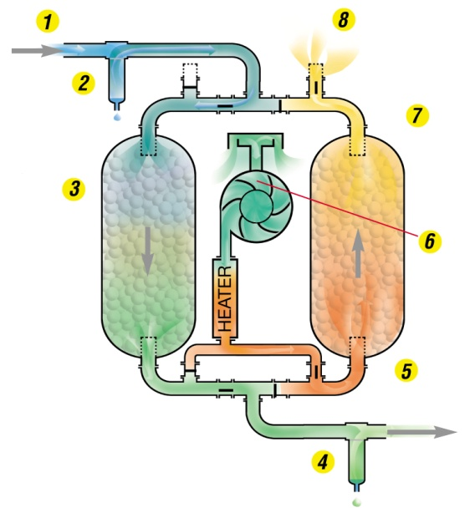

- Moist compressed air enters dryer
- Coalescing prefilter protects the dryer
- Inlet flow valve directs air through online (drying) tower. Moisture is removed (adsorbed as air flows through desiccant media. Heat-of-Adsorption aids process.
- Particulate afterfilter protects Pneumatic tools and equipment
- Dry air flows to downstream process
- Purge air is generated by blower and directed through heater then into the offline tower
- Heated purge air flows counter-current through the offline tower to regenerate desiccant media.
- Moisture is exhausted to atmosphere through muffler.

TOWER REPRESSURIZATION / DEPRESSURIZATION
- The off-line (regenerating) tower shall be gradually returned to line pressure prior to tower switching.

- Tower switch over must occur at full line pressure for the purpose of reducing desiccant dusting and premature aging of downstream filters.

- A pressure gauge on each tower shall act as a visual indicator that tower switching is occurring.

- The purge air valves shall be fitted with exhaust silencers to minimize noise level during depressurization and purging.

DESICCANT BED
Dryer shall be filled with Grade A Activated Alumina.

Desiccant shall be rated for wet air service and shall not fracture in the presence of liquid water.

Desiccant beds shall be sized to maintain both low flow velocities and maximum contact time
between wet air stream and drying desiccant.

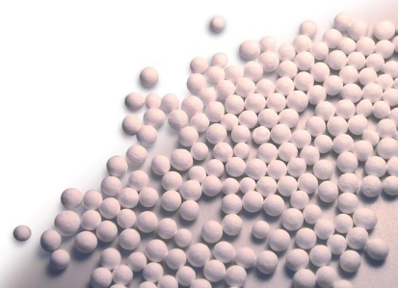

HEATED BLOWER DESICCANT AIR DRYER (Cont.)

BLOWER
The blower used in the regeneration circuit shall be regenerative or centrifugal type.

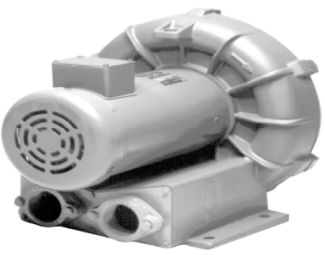

Blower shall be sized for complete regeneration air requirement.

Blower shall be equipped with a high efficiency intake filter.

CONTROLS AND INSTRUMENTATION
NEMA 4 enclosure shall be factory mounted directly on the unit and shall include the controls, indicating lights and other instrumentation required.

Drying system shall be shipped completely assembled and tested so that only single entry
electrical connection is necessary for the unit's electrical system.

Dryer sequencing shall be performed through the use of a programmable logic controller. PLC
shall provide manual stepping function to facilitate dryer sequencing and troubleshooting.

Drying system shall be provided with schematic indicating panel to indicate right and left tower drying, and right and left tower regenerating as a minimum.

Tower and purge air pressure gauges and tower temperature gauges shall be locally mounted.

EXTERNALLY MOUNTED HEATER
Heater elements mounted externally shall not come into direct contact with desiccant bed. This design minimizes thermal shock, scorching and

premature aging of desiccant caused by internally mounted heater elements.

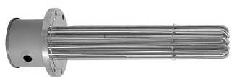

Heater shall be sized for complete regeneration air requirement. Heater shall be controlled via
solid state relay to keep heater temperature to within +/- 1.5 deg F of set point.

Heater assembly shall include direct monitoring of the heater housing. A thermocouple shall
measure the internal heater housing temperature and shut-down the heater upon High Heater Temperature condition. Interlock shall be included to prevent heater from re-energizing without being manually reset.

Externally mounted heater design shall reduce the potential for a compressed air line fire common to internal heater-type designs.

To maximize heater element service life, the heater watt density shall not exceed 23 watts per square inch.

The heater shall be Incoloy sheathed and insulated.

A temperature gauge mounted on each dryer tower shall act as a visual indicator that tower
regeneration is occurring.

ELECTRICAL
Standard enclosure is NEMA 4 and is constructed in accordance with UL/ULC 508A

Drying system shall be designed so that single entry, 460V/3PH/60HZ electrical power can be
brought into control enclosure.

HEATED BLOWER DESICCANT AIR DRYER (Cont.)

STANDARD FEATURES

NEMA 4 Electrical Enclosure
NEMA 4 enclosures protect enclosed equipment against water, seepage of water, falling or hose directed water and severe external condensation. NEMA 4 enclosures are suitable for indoors and outdoors use.

DPC Controller
Programmable Logic Controller with backlit LCD display and integral keypad. DPC Controller is specifically programmed to execute all valve switching functions as well as monitor dryer operation. Provides displays for the following functions and alarms:
- Heater High Temperature Alarm
- Failure to Shift Alarm
- Heater Failure
- Heater Operation and Temperature
- Regeneration Sequence Status
- Failure Code Storage

DynOptic™ Panel
Provides visual indication of dryer status. Includes LED indicators for:
- Dryer On
- Dryer Off / Alarm
- Left Tower / Right Tower Regeneration
- Left / Right Tower Drying
- Heater Operation

AccuTemp™ Heater Control
Innovative Solid State Relay (SSR) heater control precisely monitors temperature and operates external heater. The AccuTemp™ Controller has no moving parts to wear out, resulting in long-term reliable heater operation.

Heater High Temp Alarm with Interlock
Provides continuous monitoring of electric heater temperature control. Should heater over-temperature condition occur, an alarm is activated to alert maintenance personnel and a safety shutdown of the heater is performed to protect against heater burnout

Heater Fault Alarm
Provides continuous monitoring of electric heater operation. In the event of a heater failure, an alarm is activated to alert maintenance personnel. Should a heater fault occur, proper regeneration is lost and dew point performance erodes.

Failure to Shift
Failure to Shift option provides continuous monitoring of dryer tower pressure to ensure proper dryer operation. Should out-of-tolerance condition occur, an alarm is activated to alert service personnel.

Bi-Mode Operation
Should a heater malfunction occur, the Bi-Mode feature allows the dryer to be switched from the
standard heated mode to a heatless pressure swing operation mode. This provides system redundancy by permitting compressed air drying during heater malfunction.

Compressed Air Cooldown
For blower purge dryer applications requiring tighter dew point control, the Compressed Air
Cooldown option eliminates the preloading common to open-type blower purge dryers. During normal cooldown of open-type blower purge dryers, ambient air supplied by the blower to the regenerated desiccant bed can deposit moisture onto the desiccant.

This "preloading" may cause a dew point spike at tower- switch over. The duration and intensity of the dew point spike varies seasonally based on ambient relative humidity. To minimize dew point spikes, the Compressed Air Cooldown option utilizes a small portion of dry process air (approx. 8 - 10%) for the final one (1) hour cooldown period. Average purge consumption remains less than 2.5%.

END PRODUCT SPECIFICATION

